Short Essay on Dr. Manmohan Singh 200-250 words
Dr. Manmohan Singh is our old Prime Minister. He is a great leader in our country. He is a very honest and broad-minded leader of our country. He took the oath on May 22, 2004.
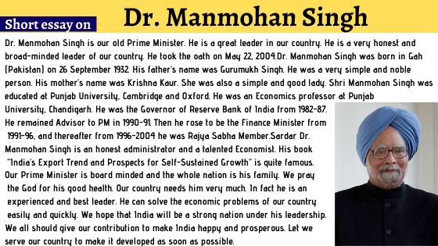
Dr. Manmohan Singh was born in Gah (Pakistan) on 26 September 1932. His father’s name was Gurumukh Singh. He was a very simple and noble person. His mother’s name was Krishna Kaur. She was also a simple and good lady. Shri Manmohan Singh was educated at Punjab University, Cambridge and Oxford. He was an Economics professor at Punjab University, Chandigarh. He was the Governor of Reserve Bank of India from 1982-87. He remained Advisor to PM in 1990-91. Then he rose to be the Finance Minister from 1991-96, and thereafter from 1996-2004 he was Rajya Sabha Member.
Sardar Dr. Manmohan Singh is an honest administrator and a talented Economist. His book “India’s Export Trend and Prospects for Self-Sustained Growth” is quite famous.
Our Prime Minister is board minded and the whole nation is his family. We pray the God for his good health. Our country needs him very much. In fact he is an experienced and best leader. He can solve the economic problems of our country easily and quickly. We hope that India will be a strong nation under his leadership.
We all should give our contribution to make India happy and prosperous. Let we serve our country to make it developed as soon as possible.

